**Are Influencers Actually Influencing Economy?**

ECO225 Project

Yuichiro Tomitsuka

1009767398

**Introduction**

With the development of the Internet, online review platforms such as Yelp have become widespread in our lives and have become an increasingly important source for us when deciding which businesses to use. Sayfuddin and Chen (2021) found that a one-star difference in a hotel's star rating is a 2.2-3.0% difference in the hotel's revenue, which was statistically significant. In addition, Luca (2016) found that an increase in a business's 1-star rating on Yelp led to a 5-9% increase in that business's revenue. These findings suggest that having a high star rating on Yelp is crucial for increasing revenues for businesses and companies. However, factors influencing a business's overall star rating are not fully understood.

One factor that could be considered a determinant of a business's overall star rating on Yelp is the number of users with followers. Reviews by a large number of followers, called influencers, have been considered more practical and valuable, which implies an increase in the credibility of reviews by influencers (Cheng, Y., & Ho, H., 2015). Therefore, influencer reviews on Yelp may gain more credibility and have a more significant impact on the overall star rating of the business rated by the influencer.

Prior research has examined influencers' reviews. Zhu, Yin, and He (2014) used a Yelp dataset and found that reviews by users with many followers helped a review receive helpful votes. A study by AlQadi et al. (2020) showed that influencers' reviews have a more significant influence on restaurant choices. Furthermore, Veirman, Cauberghe, and Hudders (2017) noted that influencers with many followers on Instagram are more likely to be likable and increase their perceived opinion leadership. According to them, this suggests that promoting products through influencers is a good choice.

These findings of previous research imply that ratings by influencers may have a more significant impact on the overall rating of a business, for influencers' reviews are perceived as likable and credible by other customers, which might encourage the use of the business and rate it likely. Furthermore, the algorithm that calculates the overall star rating is more likely to be designed so that influencer reviews are more reflected in the overall star rating. Users use Yelp to make decisions about using a business. Therefore, they want more credible reviews. Yelp may be incentivized to let credible influencer reviews have a more significant impact on the overall star rating to meet these users' demands successfully, encouraging users to keep using Yelp.

However, no study has examined the effect of star ratings by influencers on the overall reviews of restaurants on Yelp. Zhang et al. (2014) noted that a review is the most important factor in a customer's purchase decision-making. Therefore, it is vital to investigate the impact of influencers' star ratings on a restaurant's overall star rating to increase its profitability.

The research question is: Are influencer star ratings worth more than non-influencer star ratings in determining a restaurant's overall rating? We estimated the impact of influencer star ratings with over 1000 followers on Yelp on restaurant star ratings in the U.S. We found that influencer star ratings significantly influenced a restaurant's overall star rating more than non-influencer star ratings. When an influencer gave a 1-star rating, the restaurant's overall star rating was 0.272 lower than when a non-influencer gave that rating. In addition, an increase in the 1-star rating by an influencer leads to a 0.269 increase in the restaurant's overall star rating, while that of a non-influencer leads to only a 0.177 increase. It also reveals a difference in the effect of the influencer's star rating, with the restaurant's overall star rating being lower when the influencer's star rating is 1, and its rating being higher when the influencer's star rating is 5.

The remainder of this paper is organized in the following order. The data and methods used in this analysis are described after this introduction, and then our results and the conclusions of this research are discussed.

**Data**

**Yelp Dataset**

We obtained the Yelp Dataset on Kaggle. There are several subsets in this data, and we used a dataset on businesses, a dataset on reviews, and a dataset on users. First, we retrieved data on businesses that belonged to American Restaurants from the dataset about the business, which included information about the location of the business and the type of the business. We then combined that data with the data on reviews, including star ratings for the restaurant, and the data on users who reviewed the restaurant, including the number of followers, to create a single data set. The unit of this data is the review, which amounts to 2,597,957 observations. These reviews range from 2004 through 2017.

**Per Capita Income Dataset**

We web-scraped the Wikipedia site and created data on national income per capita. This data consists of per capita national income by the state in 2019 retrieved from the United States Census Bureau. We merged this per capita income data with the above dataset on the states.

**Violent Crime Dataset**

Violent crime rate data collected by the FBI's Uniform Crime Reporting (UCR) Program was obtained. These data comprised state-level violent crime rates per 100,000 from 2004 to 2017. Violent crimes are defined as the following five offenses: homicides, nonnegligent manslaughter, rapes, robberies, and aggravated assaults. Those offenses that included force and force threats were reported to the UCR and counted as violent crimes. These data were merged with the previous dataset on the year users did reviews and the states in which the restaurants are located.

**Total Parking Space Dataset**

We obtained the U.S. parking data on Kaggle. This data consisted of the number of parking spaces in U.S. cities and was merged with the previous dataset on the U.S. cities. A column of parking spaces was added to the data on reviews, showing how many parking spaces are available where the reviewed restaurant is located.

**Methodology**

**Summary Statistics**

The outcome is the overall star ratings for restaurants. As we want to examine the difference in effects of star ratings made by Influencers and Non-influencers on overall star ratings for restaurants, this variable makes sense to be used in our model. Table 1 indicates that the overall star rating for restaurants is in the range between 1 to 5 and takes on a discrete value, rounded to half-stars according to the description of the dataset. As shown in the summary statistics above, the number of restaurants is 32,466. Hence, the data is large enough to conduct research. In addition, the star rating is distributed with a mean of 3.42 and a standard deviation of 0.81. Approximately 95% of the values range from 1.83 to 5, so the distribution is slightly skewed toward high star ratings. However, it is reasonable to discuss that the distribution is not highly skewed and, thus, is appropriate as a Y variable for investigating the relationship between users' star ratings for restaurants and overall star ratings for those restaurants.

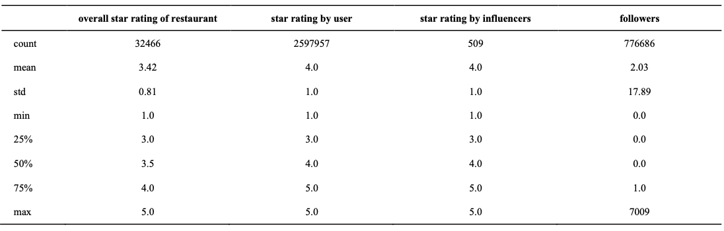

***Table 1*** Summary statitics

Star rating made by users is one of the main regressors, which can be used as an interaction term to examine the relationship between influencers' star ratings and overall star ratings for restaurants. Table 1 shows over 2,500,000 unique star ratings, so this data is large enough to examine what we want to discover in this research. Since its mean is 4 and its standard deviation is 1, circa 95% of the values range from 2 to 5. Moreover, the third quartile is 5, and the median is 4. This indicates that the distribution of this variable is skewed toward higher ratings, which corresponds to the distribution of the overall star ratings for restaurants. From this finding, it can be assumed that the star ratings by users are somewhat correlated with ratings for the restaurants. In other words, users' star ratings of a restaurant are likely to be reflected in the overall restaurant's star rating.

Influencers were defined using the number of followers. We created a dummy variable that classifies users into influencers and non-influencers to examine whether there is a difference in the effect their ratings give to the restaurant's rating. Although Table 1 indicates that the range of the values is from 0 to 7009, most users (at least 75% of users in the dataset) have only 0 or 1 followers since the third quartile is 1. Moreover, since the mean and the standard deviation are 2.03 and 17.89, respectively, over 95% of the values are from 0 to 38. Therefore, it is evident that only a few users have many followers. In other words, a few users could be considered influencers while others non-influencers. Figure 1 shows the distribution of the number of followers that each user has. The graph shows that the distribution is so highly skewed that the box cannot be seen, and most points are near 0. This statement is consistent with the summary statistics. There seem to be some outliers, but we decided not to eliminate them. This is because we consider such users with many followers as influencers. As the number of followers decreased dramatically to around 1000, we decided 1000 would be an influencer criterion. We then created a dummy variable that divides the users into two groups: Influencers and non-influencers, based on whether the users have over 1000 followers on Yelp.

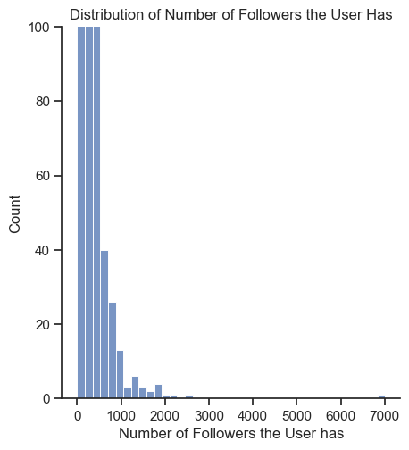

***Figure 1***

The other primary variable is the influencer's star rating. From Table 1, we can see that the star rating takes a number from 1 to 5. The mean and median are both 4, and the first quartile is also 3, indicating that the distribution of this variable is also skewed toward higher star ratings. By including this variable and the variable of user star rating, we can examine whether the effect of influencer star rating is more important than non-influencers'.

**Visualization**

Figure 2 shows the averages of the above variables in the Las Vegas zip codes in color. The darker the color, the closer the value is to 5. The left and middle figures are nearly identical, indicating that the average of the user's star rating and the average of the restaurant's overall star rating is almost identical. In other words, this suggests that the user's star rating has an impact on the restaurant's overall star rating. The figure on the right shows the average of influencers' star ratings, indicating that influencers' ratings are concentrated in the central area of Las Vegas. Compared to the left and right figures, it suggests that the average of the influencers' star ratings tends to be higher where the average overall star rating is high. This implies that influencer star ratings may significantly impact a restaurant's overall star rating.

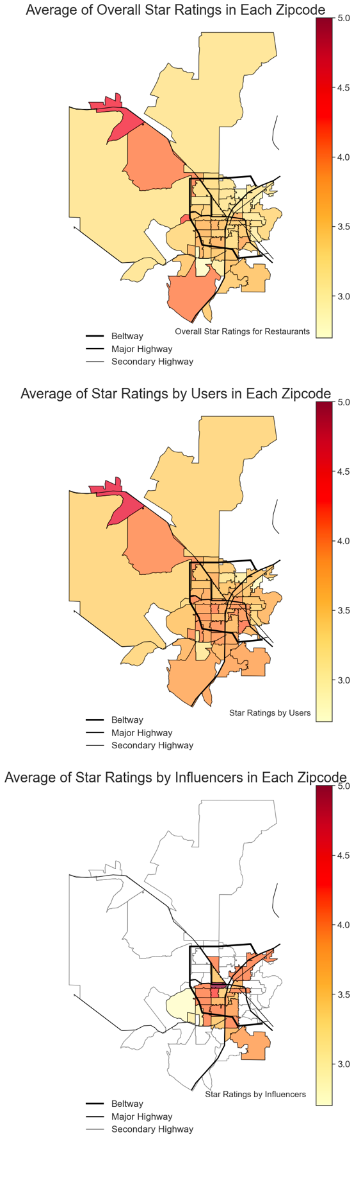

***Figure 2***

Restaurants receive a star rating from 1 to 5 from various users. Therefore, we focused on which 1 to 5-star ratings the restaurant received the most. Figure 3 shows the distribution of the restaurant's most received star ratings by overall star rating.

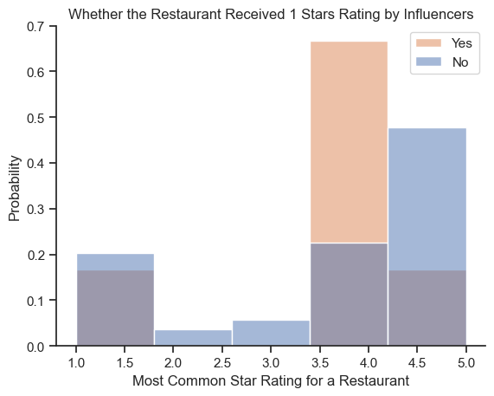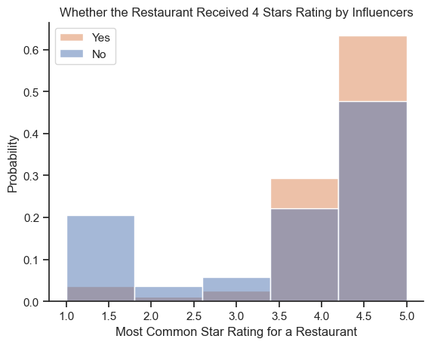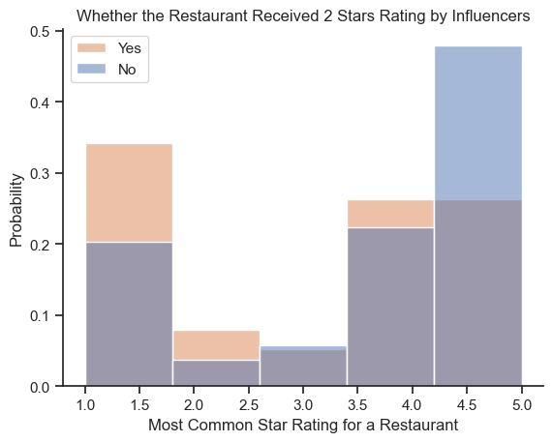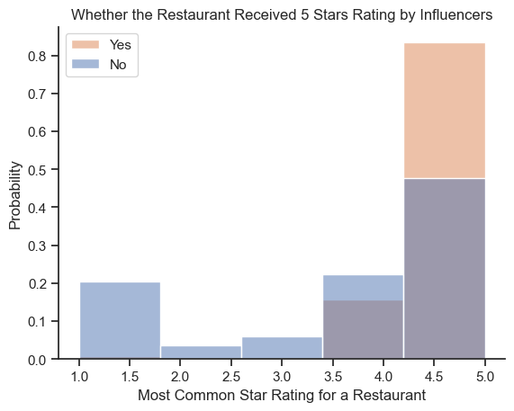

***Figure 3***

The left-top of Figure 3 shows the distribution of the most frequent star ratings for restaurants that received a 1-star rating from influencers and those that did not. We expected that the restaurant that received a 1-star rating from influencers would have the highest number of 1's, but we did not obtain that result. However, the right-top shows that restaurants that received a rating of 2 from influencers tended to receive lower star ratings, such as 1 or 2, than other restaurants. We also found that restaurants that received a star rating of 4 from influencers received higher ratings of 4 or 5 from users. Likewise, restaurants that received 5-star ratings from influencers received more 5-star ratings from users than other restaurants. Figure 3 suggests that influencers' star ratings may more significantly impact the overall star ratings for restaurants.

Furthermore, a non-linear relationship exists between users' and influencers' star ratings and the restaurant's overall rating. Figure 4 shows how the user and influencer star ratings are distributed across the overall star ratings of each restaurant. When the restaurant's overall rating is close to 1, users and influencers give a lower rating, such as 1, more often. Conversely, when the restaurant's overall rating is 5, the number of 5-star ratings is exceptionally high. This suggests that the effect of users' and influencers' star ratings on the restaurant's overall rating may increase as the restaurant's overall rating approaches 1 or 5.

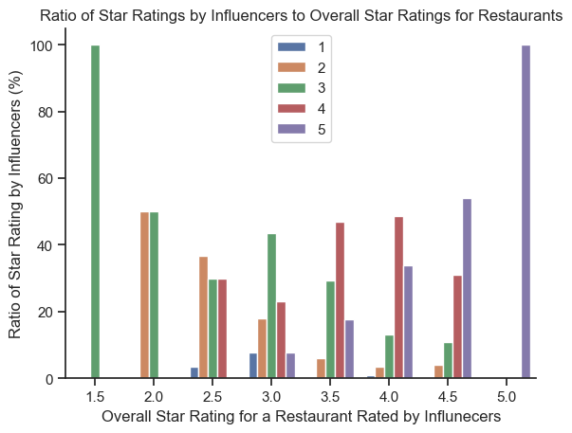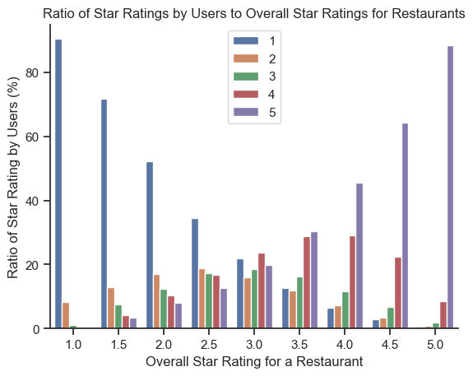

***Figure 4***

**Control Variables**

In order to obtain the effect of influencer star ratings on overall restaurant ratings, i.e., the causal effect, we need to control for factors that are determinants of overall restaurant star ratings and are correlated with influencer star ratings. More specifically, since the influencer's star rating was captured in this analysis as the intersection term of the star rating by users and the influencer dummy, we must control for factors that could be correlated with the user's star rating or the influencer dummy.

First, we controlled for the variables useful, funny, and cool votes. Yelp has a system where other users rate reviews. If a user finds a review useful, funny, or cool, he or she can give a vote for each of these. Therefore, those variables indicate the number of votes the review received. We believe the rating system works so that each review is weighted differently. Hence, reviews with more of those votes would have a more significant impact on the restaurant's overall star rating. In addition, these variables would correlate with influencer star ratings, as that influencer reviews are more likely to be seen by more people and receive those votes. For these reasons, we chose these variables as control variables.

Table 2 shows that these variables take on discrete numbers, and there is the same number of observations as that of star ratings by users. Although the maximum is 3364, 1481, and 1105 respectively, the third quartiles are 0 or 1. Moreover, the variables follow distributions with a mean of 1 and a standard deviation of less than 5. Thus, most reviews have only zero or one vote made by other users, so the distributions are highly skewed toward higher votes. This finding is consistent with the distribution of followers, which makes sense partly because the reviews by users with many followers are more likely to be paid attention to and voted on and partly because there are a few users with many followers, as mentioned above.

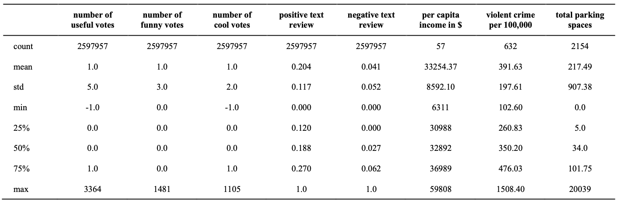

***Table 2*** Summary statistics

The second control variables are textual reviews; Yelp allows text reviews of the restaurant experience when rating stars. Gan et al. (2017) conducted a sentiment analysis of online reviews of restaurants and found that positive and negative opinions in the textual reviews influence a restaurant's overall rating. Negative and positive opinions would also be correlated with users' star ratings. Figure 5 shows the results of the text analysis for reviews where users gave a 1-star rating and a 5-star rating; there are no positive words in the text with a 1-star rating, while 5-star rating reviews have many positive words. Therefore, we should control for positive and negative text reviews.

Notes: Stopwords module in Python was used to remove word that do not indicate attributes.

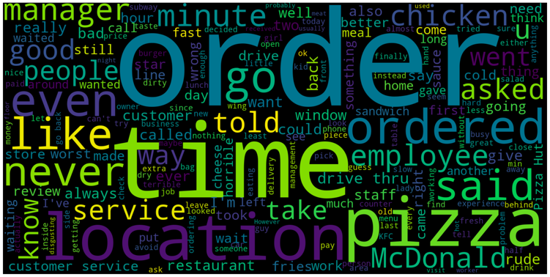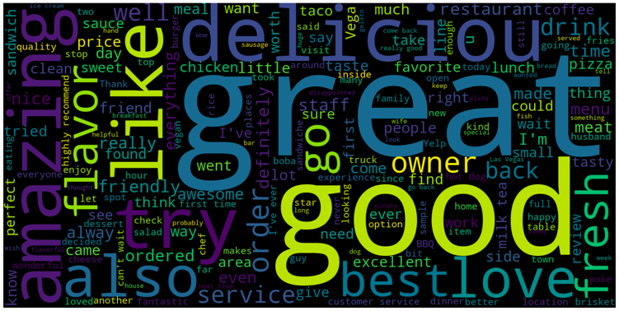

***Figure 5***

Words that appear in 1-star rating reviews

Words that appear in 5-star rating reviews

Sentiment analysis is a machine learning method of natural language processing to discover how much a text contains positive, neutral, or negative elements. We used the SentimentIntensityAnalyzer() method, a Python module, to perform sentiment analysis on each text. As Table 2 shows, these variables indicate the percentage of the text that is classified as positive or negative attitude. The average of the positive component is about 20%, while the average of the negative component is lower, at about 4%. This indicates a high percentage of neutral elements in many texts.

The third control variable is per capita income; Bakhshi et al. (2014) find that exogenous geographic factors, including education, severely affect restaurant reviews. Moreover, income is traditionally used as a proxy for education (Ware, 2017). Therefore, we believe that per capita income can influence a restaurant's overall star rating and add it to the model as a control variable. Table 2 shows that this variable is per capita income in states and certain boroughs with 57 observations.

The fourth control variable is the number of crimes; according to Hu, Sun, and Liu (2014), a business's reputation is determined by the endogenous factors that characterize it and its geographical neighbors. Another study by Heung and Gu (2012) found that the restaurant's ambiance influences customer satisfaction. Taken together, we believe the neighborhood's atmosphere influences customers' perception of the restaurant. Therefore, we focused on the geographic factor, the number of crimes. Figure 6 indicates that the higher the number of crimes, the worse the neighborhood ambiance, the worse the restaurant experience, and the lower the star rating. This means that the number of crimes should impact the restaurant's rating. Table 2 shows that the third quartile is 476, with a maximum value of 1508.4, suggesting that this variable is skewed.

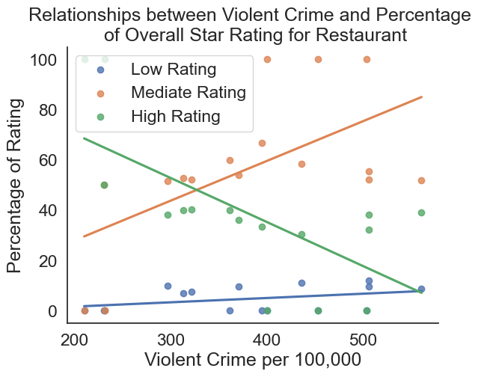

***Figure 6***

Finally, the number of parking spaces in the city where the restaurant is located was considered as a control variable; Liu and Tse (2018) cite Walking Distance as an influence on restaurant ratings. Since cars are the most commonly used mode of transportation in the U.S., the walking distance to a restaurant depends on how many parking spaces are available near the restaurant. Therefore, the number of parking spaces is included in the model as a proxy for a walking distance that has an effect on restaurant evaluation. The unit for this variable is the number of parking spaces in the city. Therefore, Table 2 shows that 2154 cities are included in the data. The table also indicates that there are outliers since the mean and the maximum are 217 and 2039, respectively, which might be due to the inclusion of large cities in the data.

**Model**

Based on these discussions above, we run a multiple regression analysis to estimate the effect of influencer star ratings on a restaurant's overall star rating. The primary model for this research is as follows:

$$OverallStarRestaurant_{i}=β_{0}+β_{1}StarUser_{i}+β_{2}{\left(StarUser_{i}\right)}^{2}+β_{3}{\left(StarUser_{i}\right)}^{3}+β_{4}Influencers_{i}+β_{5}StarUser_{i}×Influencers_{i}+β_{6}{(StarUser_{i}×Influencers_{i})}^{2}+{β_{7}(StarUser_{i}×Influencers_{i})}^{3}+γ_{1}UsefulVotes_{i}+γ_{2}FunnyVot{es}_{i}+γ_{3}CoolVotes_{i}+γ_{4}PosText_{i}+γ_{5}NegTe{xt}_{i}+γ_{6}Income_{i}+γ_{7}Crime_{i}+γ_{8}Parking_{i}+u_{i}$$

By including an interaction term between the influencer dummy and the star rating by the user, we can see the effect of the influencer's star rating. Moreover, by including the squared and cubed terms, we capture the previously noted hypothesis that the marginal effect of influencer star ratings on overall restaurant ratings is not constant.

**Results**

Table 3 shows the regression analysis results, with the statistically significant result that influencers' star ratings had a more substantial effect on the restaurant's overall star rating. We also found that the effect was also non-linear, with a relationship between lower star ratings and higher overall restaurant star ratings when star ratings were lower and higher, respectively. However, the effect was not very large, and there was no economically significant difference between the effect of the influencer's star rating on the restaurant's overall rating and the effect of the star rating by other users.

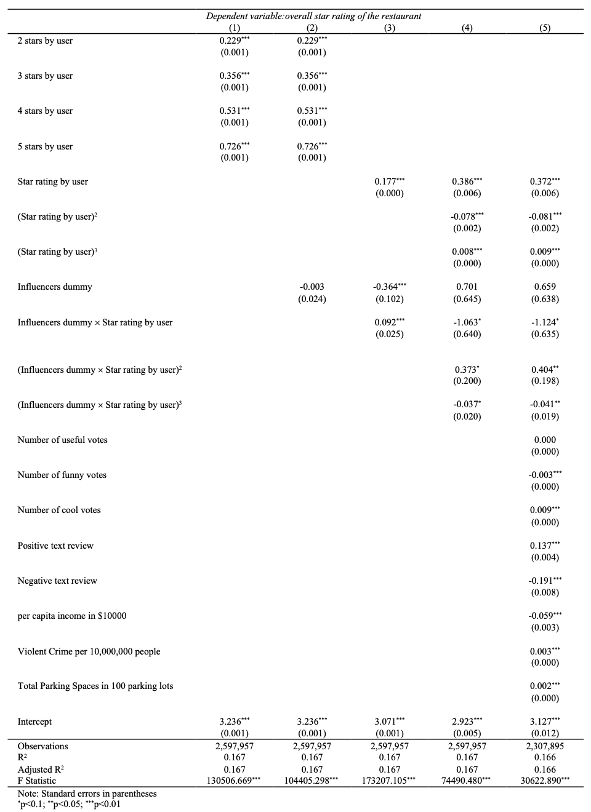

***Table 3***

Specification 1 in Table 3 is a model that includes only user star ratings, and we obtain that the coefficients for all ratings from 1 to 5 are significant at the 1% significance level. This means a statistically significant relationship exists between the user's star rating and the restaurant's overall rating. The intercept in this model represents the average of the restaurant's overall rating when the user's star rating is 1, which is 3.236. The coefficient of each variable represents the difference from its intercept. The average overall star rating of the restaurants was 3.645 when the user rated it 2 stars, and the average overall star rating was 3.592 when the user rated it 3 stars. When the user rated it 4 stars, the average was 3.767; when it rated it 5, the average was 3.962. Figure 7 shows the results of this model, noting that the higher the user's rating, the higher the restaurant's overall rating.

***Figure 7***

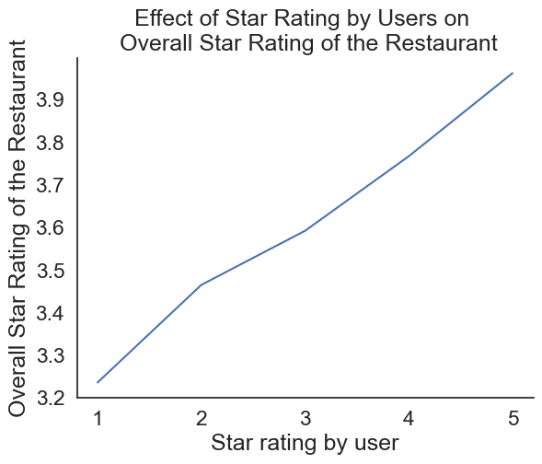

Specification 2 in Table 3 represents the model that adds the influencer dummy variable to Specification 1, and the influencer dummy coefficient was not statistically significant. As the values of the other coefficients and their statistical significance are unchanged, adding only the dummy variable to the model is not valid.

Specification 3 in Table 3 shows that the coefficient of influencer star ratings is significant at the 1% level, suggesting a significant difference between the effect of influencer star ratings on restaurant ratings and other users' star ratings. The marginal effect of non-influencer star ratings is 0.177, meaning that one increase in their ratings would increase the restaurant's overall star rating by 0.177. The interaction term between influencer and user star ratings is added to the model to account for the influencer's star rating. Its coefficient, which represents the difference between the marginal effect of the influencer's star rating and the other user's star rating, is 0.092 and statistically significant. In other words, one increase in the influencer's star rating means a 0.269 increase in the restaurant's overall rating. Unlike Specification 2, the coefficient for the influencer dummy is significant at the 1% level, suggesting that the interaction term changes the effect of the dummy variable and should be included in the model. Figure 8 illustrates the results of this model, showing that the influencer's star rating has more influence on the restaurant's overall star rating since when the influencer's star rating is 1, the restaurant's overall star rating is lower than when other users gave the same rating. In addition, this is because when the influencer's star rating is 5, the restaurant's overall star rating is higher than when other users gave a rating of 5.

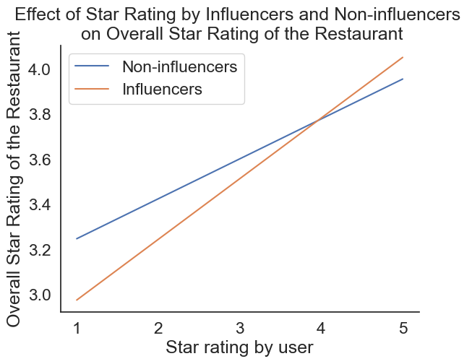

***Figure 8***

Neither the effect of non-influencer star ratings nor the effect of influencer star ratings is economically significant. The standard deviation of star rating by users is 1, so one standard deviation change in the star rating would be a 0.177 difference in the overall star rating of restaurants. While the standard deviation of the overall star rating of restaurants is 0.807681, one standard deviation difference in star rating by users is only associated with only 22% of a standard deviation in the overall star rating for restaurants. In addition, one standard deviation change in an influencer's star rating would be 0.269 since its standard deviation is 1. Thus, one standard deviation change is only related to 33%. These findings suggest that both effects are relatively small.

Specification 4 in Table 3 further adds the squared and cubed terms of the variables for non-influencer and influencer star ratings. These variables show whether there is a difference in the effect on the restaurant's overall star rating when the star rating by users is extremely low, high, or mediate, as when the star rating is 3. The coefficients of the variables for the non-influencer star rating all showed statistical significance at the 1% level. However, all of the coefficients for the variables for influencers did not yield significant results at the 5% confidence level.

Specification 5 in Table 3 shows that the coefficients for the influencer star rating variable are significant at the 5% level. This is the primary model of this research, including control variables that were considered to be determinants of the restaurant's overall rating and correlated with our primary X variable, the variable of star rating by users. Specifically, the coefficients of the squared and cubic terms of the interaction term of the influencer dummy variable and the user's star rating variable are significant at the 5% level. Although the interaction term and the dummy variable are not statistically significant, the statistical significance of the squared and cubed terms supports the idea that the effect of influencer star ratings is different from that of non-influencer star ratings and that the effect is not linear. Figure 9 illustrates these effects, showing that influencer and non-influencer star ratings have an S-curve relationship with the restaurant's overall star rating. In other words, when both influencer star ratings and non-influencer star ratings are close to 1, the restaurant's overall star rating is substantially reduced, while the restaurant's overall star rating significantly increases when they differ by 5. Moreover, compared to the non-influencers' star ratings, the influencers' overall star rating of the restaurant is lower when the influencers' star rating is 1 and higher when the non-influencers' star rating is 5. Therefore, the results indicate that the influencers' overall star rating is more valuable than the non-influencers'. However, the difference in the effect on star ratings by influencers and non-influencers is at most about 0.2, so this difference is only associated with 25% of a standard deviation in the overall star rating of restaurants. Thus, the effect of star rating by influencers is relatively small and not economically significant.

***Figure 9***

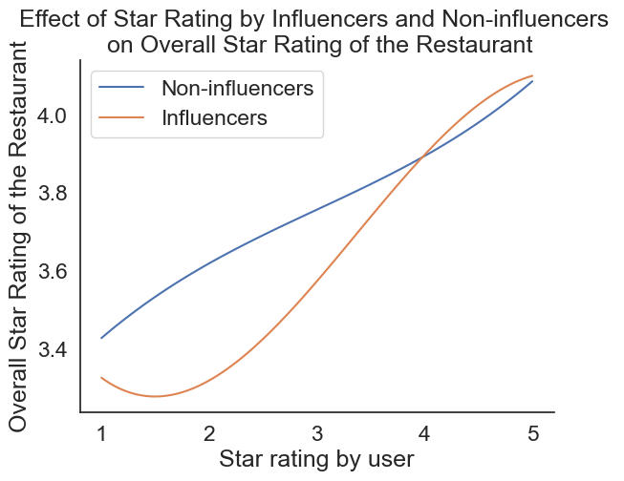

The F-values for all of these models are significant at the 1% level, indicating that all models are statistically meaningful. In addition, there is no significant difference in the R-squared of each model. The value of the R-squared is 0.17, indicating that the independent variable in any of the models explains about 17% of the variation in the dependent variable. The fact that there is no significant difference in the R-squared of each model suggests that the users' star ratings explain about 17% of the variation in the dependent variable. In contrast, the other variables explain very little. This is consistent with the lack of economic significance in the effect of influencer star ratings and the fact that the coefficients of most control variables are also statistically significant but that their effects are negligible.

**Conclusion**

This research examined whether influencer star ratings have a more significant effect on a restaurant's overall star rating than non-influencer star ratings. Currently, Yelp is frequently used when deciding which restaurant to eat at, and star ratings are becoming increasingly important. Morais (2022) also points out that with the development of social media, influencers have emerged, and influencers' reviews significantly affect customers' decisions about which restaurants to visit. Therefore, companies need to increase the star rating of influencers with many followers for their restaurants. However, past research has not examined how this influencer star rating affects a restaurant's overall star rating. Hence, this research provides meaningful implications for restaurant management.

Through multiple regression analysis, this research paper found that influencer star ratings are more reflected in a restaurant's overall star rating. We found that a restaurant's overall star rating was 0.272 lower when influencers rated the restaurant as 1 star than when non-influencers rated the restaurant as 1 star. The evidence also showed that an increase of a 1-star rating by non-influencers raises the restaurant's overall star rating by 0.177, while the effect is higher for influencers at 0.269. In addition, extreme star ratings, such as 1 and 5, had a greater effect than the other ratings, which was statistically significant. However, none of the effects were associated with only about a 20-30% standard deviation difference in the restaurant's overall star rating, which raises the question of whether the results give a critical implication to actual restaurant management.

Some limitation exists in the analysis of this research. First, the models used in this research are subject to omitted variable bias. The results of this research cannot refer to causality because there are variables that affect the overall star rating of the restaurant that could not be included in this model and are correlated with the user's star rating. Therefore, more advanced econometric methods, such as IV regression, need to be used to estimate the causal effect of the influencer's star rating on the restaurant's overall star rating. Furthermore, the model does not consider that an influencer's star rating for a restaurant can affect the star ratings of other users. It is assumed that more users will visit a restaurant highly rated by an influencer and rate it equally. Therefore, the variables of user star ratings are correlated, which might make the results in this paper biased. Therefore, future analysis should consider whether influencers' star ratings could influence other users.

In this study, we focused on restaurant ratings. However, there are other industries, such as tourism, where influencer ratings can significantly impact. Understanding the impact of influencer evaluations in such industries will have significant implications for management strategies in those industries. Therefore, we firmly believe that future research should investigate the impact of ratings by influencers in other industries.

**Work Cited**

AlQadi, R., Al-Nojaidi, H., Alabdulkareem, L., Alrazgan, M., Alghamdi, N., & Kamruzzaman, M. (2020). How Social Media Influencers Affect Consumers' Restaurant Selection: Statistical and Sentiment Analysis. *2020 2nd International Conference on Computer and Information Sciences (ICCIS)*, 1-6, doi: 10.1109/ICCIS49240.2020.9257636.

Bakhshi, S., Kanuparthy, P., & Gilbert, E. (2014). Demographics, weather and online reviews: A study of restaurant recommendations. *Association for Computing Machinery*, 443-454

Cheng, Y., & Ho, H. (2015). Social influence's impact on reader perceptions of online reviews. *Journal of Business Research*, 68(4), 883-887.

Gan, Q., Ferns, B., Yu, Y., & Jin, L. (2017). A Text Mining and Multidimensional Sentiment Analysis of Online Restaurant Reviews. *Journal of Quality Assurance in Hospitality & Tourism*, 18(4), 465-492.

Heung, V., & Gu, T. (2012). Influence of restaurant atmospherics on patron satisfaction and behavioral intentions. *International Journal of Hospitality Management*, 31(4), 1167-1177.

Hu, L., Sun, A., & Liu, Y. (2014). Your neighbors affect your ratings: on geographical neighborhood influence to rating prediction. *Association for Computing Machinery*, 345-354.

Liu, P., & Tse, E. C. (2018). Exploring factors on customers' restaurant choice: An analysis of restaurant attributes. *British Food Journal*, 120(10), 2289-2303.

Luca, M., (2016). Reviews, Reputation, and Revenue: The Case of Yelp.Com. *Harvard Business School NOM Unit Working Paper*, 12(016).

Morais, L., S. (2022). The impact of influencers on restaurants reviews: a Tripadvisor case. *Master Program in Information Management*. Retrieved from https://run.unl.pt/handle/10362/136694

Sayfuddin, A., & Chen, Y. (2021). The signaling and reputational effects of customer ratings on hotel revenues: Evidence from TripAdvisor. *International Journal of Hospitality Management*. 99.

Veirman, M., Cauberghe, V., & Hudders, L. (2017). Marketing through Instagram influencers: the impact of number of followers and product divergence on brand attitude, *International Journal of Advertising*, 36(5), 798-828.

Zhang, K., et al. (2014). Examining the influence of online reviews on consumers' decision-making: A heuristic–systematic model. *Decision Support Systems*. 67, 78-89.

Zhu, L., Yin, G., & He, W. (2014). Is this opinion leader's review useful? Peripheral cues for online review helpfulness. *Journal of Electronic Commerce Research*. 15(4). 267-280

Ware, J. (2017). Property Value as a Proxy of Socioeconomic Status in Education. Education and Urban Society. 51(1), 99-119.

**Dataset**

**Yelp Dataset:** Yelp Dataset. (last updated 2021). *Kaggle*. Owned by Yelp Inc. and Edited by Crawford, C. Retrieved from https://www.kaggle.com/datasets/yelp-dataset/yelp-dataset

**Per Capita Income Dataset:** List of U.S. states and territories by income. *Wikipedia*. Retrieved from https://en.wikipedia.org/wiki/List_of_U.S._states_and_territories_by_income

**Violent Crime Dataset:** FBI Crime in the U.S. (2004-2017). *FBI: UCR*. Retrieved from https://ucr.fbi.gov/crime-in-the-u.s

**Total Parking Space Dataset:** U.S. Parking Data. (last updated 2021). *Kaggle*. Created by Qureshi, F. Retrieved from https://www.kaggle.com/datasets/mfaisalqureshi/parking